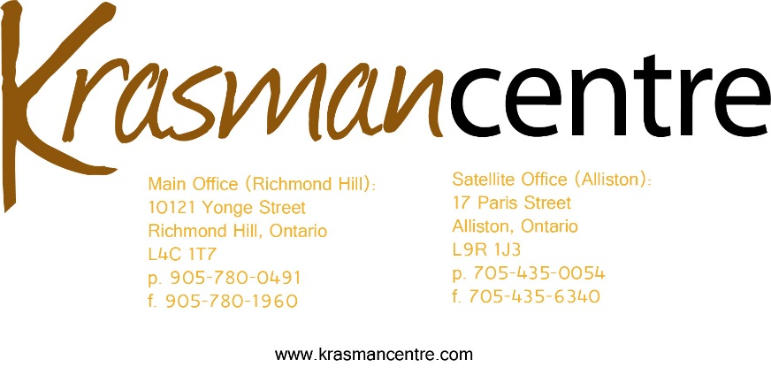

Organizational Review and Design Project

Krasman Centre is issuing a Request for Proposals for a consultant(s) to conduct an Organization Review and Design Project. We require a self-motivated person of integrity who is able to skillfully conduct this project to completion.

The Organizational Review and Design Project will - assess current processes and systems in order to ensure the organization’s viability and success. This will include examination of roles and responsibilities of staff as well as review of our programmatic structure; our business operations; and our external relations. The consultant will provide a review and renewal of the agency’s strategic plan and make recommendations for redesign and improvements to the organization as identified. The consultant will provide a 3rd party review/assessment of the organizational structure and available resources in order to find efficiencies and best usage of the staffing resources we currently have, to ensure utmost quality of service on all levels.

Incorporated in 1998, Krasman Centre is a mental health and addiction consumer/survivor initiative in York Region. As such, all of our staff and volunteers are individuals with lived experience of mental health and/or addiction challenges who have been able to find wellness and recovery along our respective journey’s. Our programs and services include; Peer Support Drop-In Centres; a 24 hour 7 day/week Warm Line; Family Support Program; Peer Supporters in 2 Hospital Emergency Departments; Peer Support Outreach; recovery education groups; and an Application Support Worker. Our services are delivered by a staff team of 14 full-time equivalents. This review project will work to improve work-flow processes to ensure that the agency runs as efficiently as possible; and enhances the effectiveness of our programs for service users. It will also improve the work experience and current challenges faced by our staff team, and will potentially increase the volume of services and supports we are able to provide.

More information about Krasman Centre can be found here: www.krasmancentre.com

Proposed Scope of Work:

- Meeting with Krasman Centre staff leadership and Board of Directors and Board liaison to discuss the goals of the project.
- Organizational Review – review staff roles and responsibilities, our programmatic structure; our business operations; and our external relations.
- Create, coordinate, and facilitate internal communication related to the progress of the project.
- Review and renewal of agency’s strategic plan
- Organizational Design – Recommend new operational processes and redesign tools based on the review process to improve efficiency and effectiveness, while ensuring ongoing quality improvement.
- Produce a plan for monitoring and adjusting workflow as gaps or blockages are encountered.
- Co-creation of evaluation metrics to measure progress
- Produce final report on the project.

Krasman Centre will select a consultant(s) based on the quality of the proposal and the demonstrable expertise of the consultant(s). The consultant will have extensive knowledge in mental health and addictions and the social issues surrounding the catchment area of the agency. Preference is given to individuals with lived experience of mental health/addiction issues who have gone through a process of recovery and have obtained peer support related training to assist others with mental health challenges to identify and achieve life goals as part of their own recovery.
The consultant should also have an in-depth knowledge and understanding of the Peer Support Movement, development, design and operations of Consumer/Survivor Initiatives, as well as supervision and management of Peer Support Workers.

The written proposal must include:

- A description of relevant experiences
- Work plan for the project including activities, timelines, and support required from the organization.
- Budget for the project including consultant’s fees and any expenses.
- Resume/CV for the consultant(s) who will be involved in the project.

The Krasman Centre welcomes and encourages applications from people with disabilities. Accommodations are available upon request for candidates taking part in all aspects of the selection process.

Please submit proposals to: Susan Dobson, Executive Director
Email: s.dobson@krasmancentre.com

Deadline for proposal submission: Friday March 10th, 2017.

This program is funded through the Regional Municipality of York

